



MAJOR PROJECT REPORT


Prepared by:
29.06.2026
ANNAM JALANDHARA


Title
Titanic Survival Prediction using Machine Learning and Power BI Dashboard
- Introduction
The Titanic disaster is one of the most well-known historical events and has become a widely used dataset for learning data analytics and machine learning. This project focuses on analyzing passenger information, cleaning the dataset,
exploring patterns through visualizations, building a predictive machine learning model, and presenting insights using an interactive Power BI dashboard.
The project demonstrates a complete data analytics workflow from raw data preprocessing to predictive modeling and visualization.

- Objective
- Clean and preprocess the Titanic dataset.
- Perform exploratory data analysis (EDA).
- Identify factors affecting passenger survival.
- Build a Decision Tree machine learning model.
- Evaluate the model using accuracy.
- Develop an interactive Power BI dashboard.
- Demonstrate an end-to-end analytics workflow.
- Dataset Description
- Dataset: Titanic Dataset
- Source: Kaggle
- Total Records: 891
- Features:
- PassengerId
- Survived
- Pclass
- Name
- Sex
- Age
- SibSp
- Parch
- Ticket
- Fare
- Cabin
- Embarked


- Methodology
Data Collection
↓
Data Cleaning
↓
Exploratory Data Analysis
↓
Feature Engineering
↓
Machine Learning
↓
Model Evaluation
↓
Power BI Dashboard

- Data Cleaning
- Loaded dataset
- Checked missing values
- Filled Age with median
- Filled Embarked with mode
- Removed Cabin
- Removed duplicates
- Saved cleaned dataset

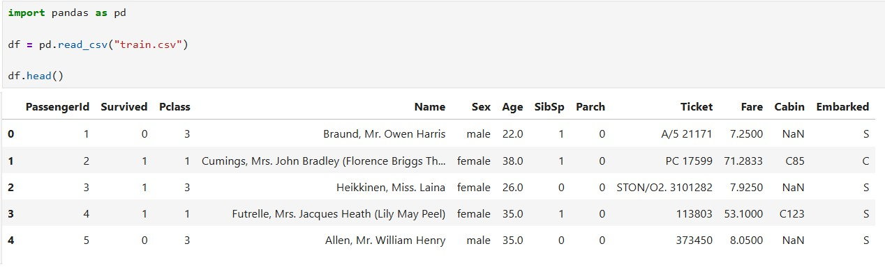


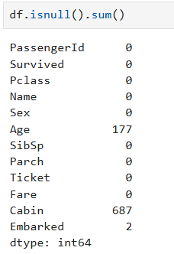

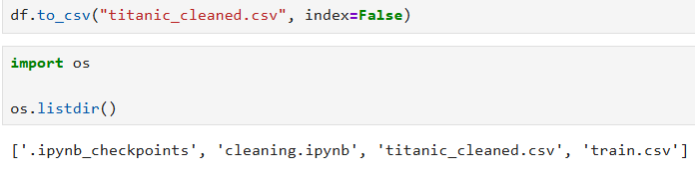

- Exploratory Data Analysis:


  - Survival Count
This chart shows the number of passengers who survived and those who did not survive the Titanic disaster. The analysis indicates that the number of passengers who did not survive was higher than the number of survivors.
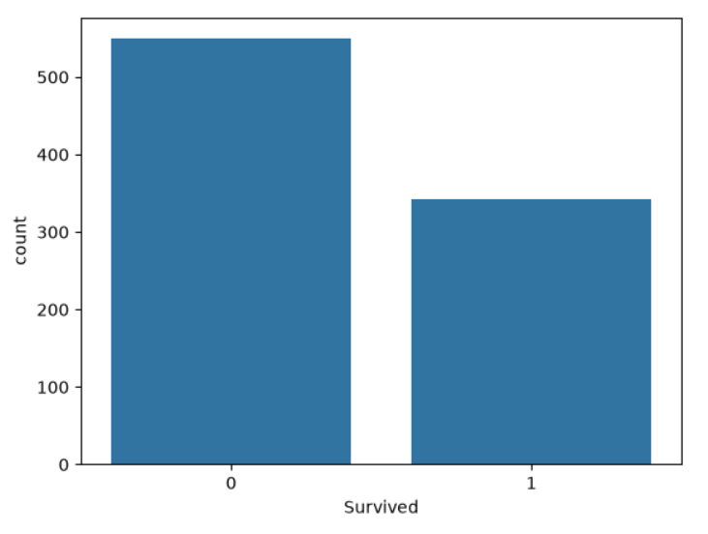

  - Gender Distribution
This chart illustrates the distribution of male and female passengers on board. The dataset contains a larger number of male passengers compared to female passengers.

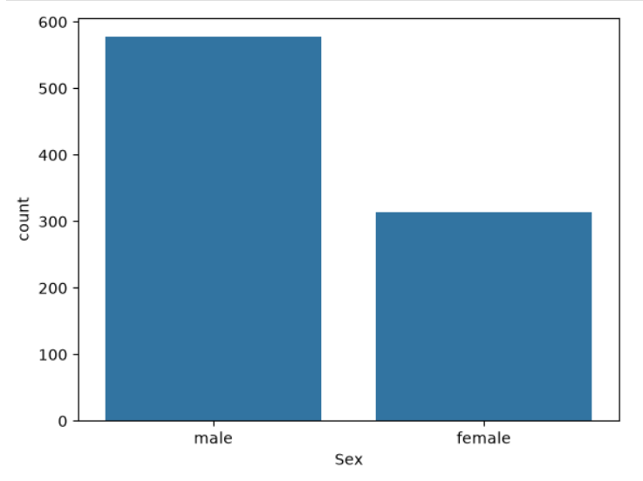


  - Male vs Female Survival
This visualization compares the survival status of male and female passengers. It shows that female passengers had a significantly higher survival rate than male passengers.
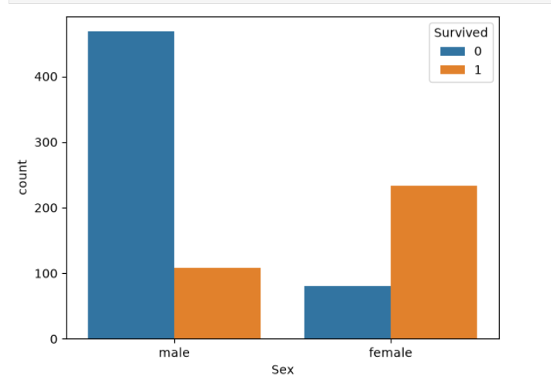

  - Age Distribution
The age distribution chart shows that most passengers were between 20 and 40 years old. There were comparatively fewer passengers in the younger and older age groups.
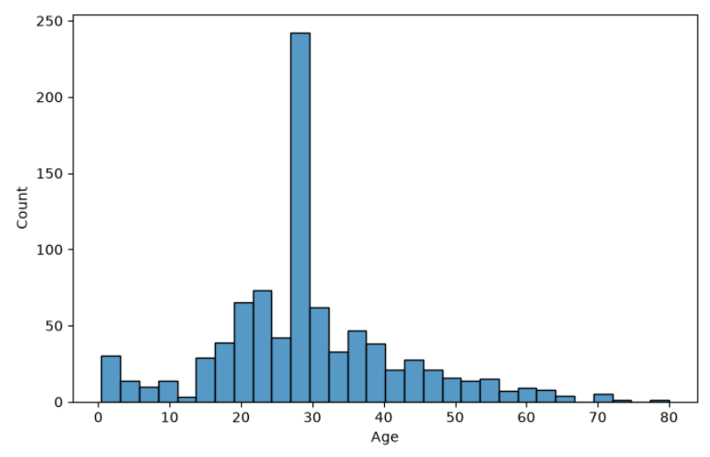


  - Passenger Class vs Survival
This chart compares passenger survival across different ticket classes. First-class passengers had the highest survival rate, while third-class passengers
experienced the highest number of fatalities.

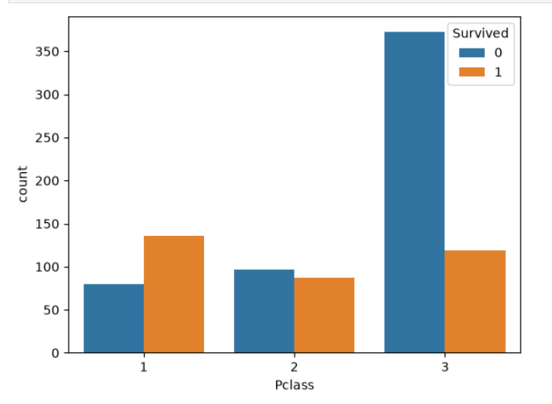

  - Correlation Heatmap
The correlation heatmap displays the relationship between numerical features in the dataset. It helps identify which variables have positive or negative correlations with passenger survival and provides insights for further analysis.

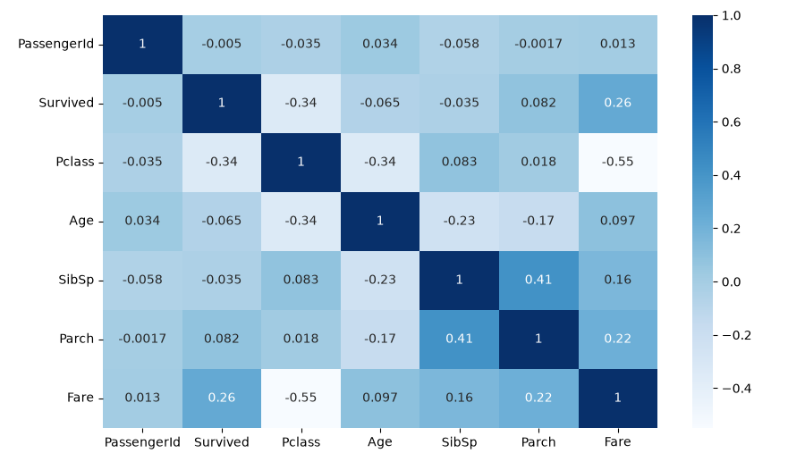


- Algorithm Used:
Decision Tree Classifier
- Features Used:
- Pclass
- Sex
- Age
- SibSp
- Parch
- Fare
- Embarked
- Target Variable:
Survived

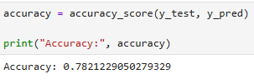
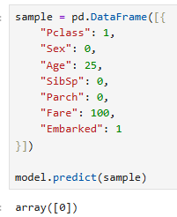

The Decision Tree Classifier was trained using the cleaned Titanic dataset. The model was evaluated using accuracy on the test dataset and successfully
predicted passenger survival based on the selected features.


- Dashboard:
The dashboard provides an interactive visualization of passenger survival, gender distribution, passenger class, age distribution, and other key insights. It enables users to explore the dataset visually and understand survival trends.

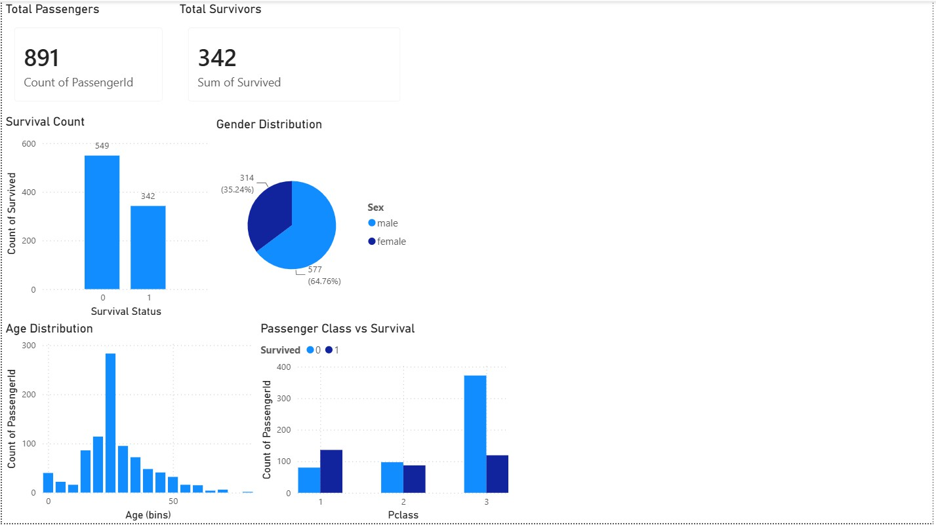

- Tools Used:
Python
Jupyter Notebook Pandas
NumPy Matplotlib Seaborn Scikit-learn Power BI


- Results:
- Successfully cleaned and prepared the Titanic dataset.
- Performed exploratory data analysis to identify survival patterns.
- Built a Decision Tree Classifier for survival prediction.
- Evaluated model performance using accuracy.
- Developed an interactive Power BI dashboard for visualization.

- Conclusion:
This project demonstrates a complete data analytics and machine learning pipeline using the Titanic dataset. Through data preprocessing, visualization, predictive modeling, and dashboard development, meaningful insights were extracted and presented effectively. The project strengthened practical skills in Python, machine learning, and business intelligence tools.

